

**THE IMAGINATION UNIVERSITY PROGRAMME**

**RVfpga-SoC Lab 4**

**Running Zephyr on SweRVolf**

**Table 1. RVfpga Terms**

|  |  |
| --- | --- |
| **Name** | **Description** |
| **Courses** | |
| **RVfpga** | A course that shows how to use RVfpgaNexys and RVfpgaSIM, RISC-V system-on-chips (SoCs), to run programs and extend the system by adding peripherals (RVfpga Labs 1-10), and explore the core and memory system by running simulations, measuring performance, adding instructions, and modifying the memory system (RVfpga Labs 11-20). Throughout the course, users are also shown how to use the RISC-V toolchain (compilers and debuggers) and simulators, the Verilator HDL simulator, and Western Digital’s Whisper instruction set simulator (ISS). |
| **RVfpga-SoC** | A course that shows how to build a subset SweRVolfX SoC from scratch using building blocks such as the SweRV core, memories, and peripherals. The course also shows how to load the Zephyr real-time operating system (RTOS) onto SweRVolf and run programs including Tensorflow Lite’s hello world example on top of the operating system. |
| **Cores and SoCs** | |
| **SweRV EH1 Core** | Open-source commercial RISC-V core developed by Western Digital  (<https://github.com/chipsalliance/Cores-SweRV>). |
| **SweRV EH1 Core Complex** | SweRV EH1 core with added memory (ICCM, DCCM, and instruction cache), programmable interrupt controller (PIC), bus interfaces, and debug unit (<https://github.com/chipsalliance/Cores-SweRV>). |
| **SweRVolfX** | The System on Chip that we use in the RVfpga course. It is an extension of SweRVolf.  **SweRVolf** (<https://github.com/chipsalliance/Cores-SweRVolf>): An open-source SoC built around the SweRV EH1 Core Complex. It adds a boot ROM, UART interface, system controller, interconnect (AXI Interconnect, Wishbone Interconnect, and AXI-to-Wishbone bridge), and an SPI controller.  **SweRVolfX**: It adds four new peripherals to SweRVolf: a GPIO, a PTC, an additional SPI, and a controller for the 8 Digit 7-Segment Displays. |
| **RVfpgaNexys** | The SweRVolfX SoC targeted to the Nexys A7 board and its peripherals. It adds a DDR2 interface, CDC (clock domain crossing) unit, BSCAN logic (for the JTAG interface), and clock generator.  RVfpgaNexys is the same as SweRVolf Nexys (<https://github.com/chipsalliance/Cores-SweRVolf>), except that the latter is based on SweRVolf. |
| **RVfpgaSIM** | The SweRVolfX SoC with a testbench wrapper and AXI memory intended for simulation.  RVfpgaSim is the same as SweRVolf sim, (<https://github.com/chipsalliance/Cores-SweRVolf>), except that the latter is based on SweRVolf. |

# Introduction

In this Lab, we show how to run the Zephyr real-time operating system (RTOS) on SweRVolf. A real-time operating system (RTOS) is an operating system intended to serve real-time applications that process data as it comes in, mostly without buffer delay.

In Labs 2 and 3, we have been running simple programs written in the RISC-V assembly or C language. In practical applications, an SoC will almost always be running an operating system, and applications will be running on top of the operating system.

Two overall categories of operating systems for embedded systems exist: embedded Linux-based operating systems and real-time operating systems (RTOS). When an SoC is designed with a particular CPU, the design is usually tuned to use one or the other type of operating system. SweRVolf was built with the intention of running a real-time operating system. The SweRV EH1 CPU does not have a memory management unit and would, thus, struggle to run embedded Linux.

Figure 1 shows an illustration of the different hardware/software layers in the overall system.

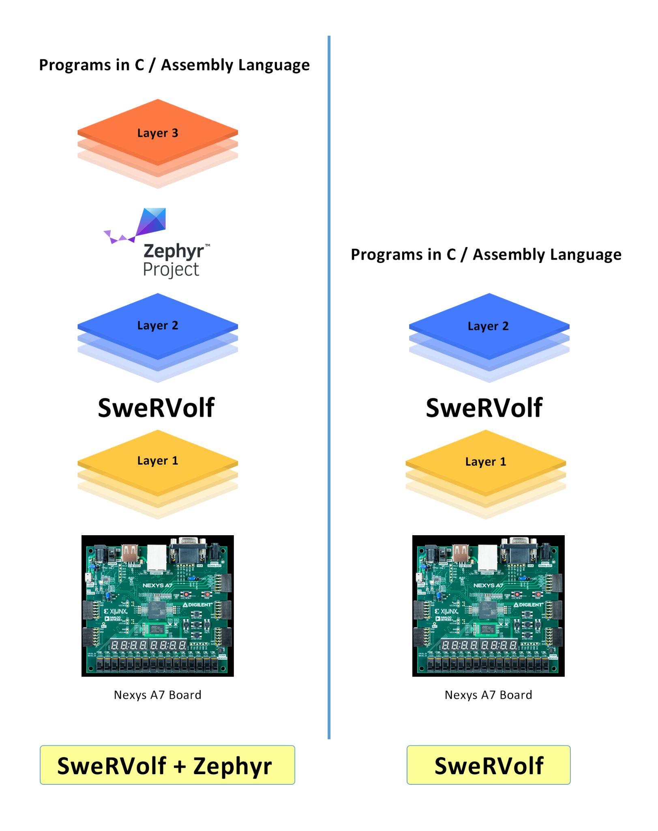

**Figure 1. Layers on the top of FPGA Boards**

In this Lab, we will describe the Zephyr RTOS, build and run the Zephyr RTOS on SweRVolf, and build & run Zephyr applications.

# Requirements

To complete this lab, you will need to install the following:

* Vivado 2019.2 Web Pack (Refer to Installation Guide (Page No.04))
* Verilator (v4.106) (Refer to Installation Guide (Page No.08))
* FuseSoC (Refer to Installation Guide (Page No.09))
* OpenOCD (RISC-V-specific version) (Refer to Installation Guide (Page No.09))
* Zephyr Prerequisites (Refer to Installation Guide (Page No.10))
* Zephyr SDK (v0.12.4) (Refer to Installation Guide (Page No.10))
* PuTTY (Refer to Installation Guide (Page No.11))

**IMPORTANT:** Before starting RVfpga-SoC Labs, we highly recommend completing the RVfpga-SoC Installation Guide.

For example, if you have not already, install Xilinx’s Vivado and Verilator following the instructions in the RVfpga-SoC Installation Guide. Make sure that you have copied the RVfpga-SoC folder that you downloaded from Imagination’s University Programme to your machine.

# Zephyr Overview

The Zephyr Project is a scalable real-time operating system supporting multiple hardware architectures, optimized for resource-constrained devices, and built with security in mind. The Zephyr OS is based on a small-footprint kernel designed for use on resource-constrained systems: from simple embedded environmental sensors and LED wearables to sophisticated smart watches and IoT wireless gateways.

Zephyr offers a number of familiar services for development: Multi-threading, Interrupts, Memory Allocation, Inter-thread Synchronization, Inter-thread Data Passing, and Power Management.

Zephyr supports a wide variety of boards with different CPU architectures and developer tools. Contributors have added support for an increasing number of SoCs, platforms, and drivers.

The Zephyr kernel supports multiple architectures, including:

* RISC-V (32- and 64-bit)

For more detailed information on the Zephyr Project, read the Zephyr project documentation at [http://docs.zephyrproject.org](http://docs.zephyrproject.org/).

In this lab, we first show how to add Zephyr’s version 2.4 to our Workspace. Then we will build the code for a few sample examples that come with Zephyr. This lab will show examples of using Zephyr both in hardware and simulation.

# Understanding the Hardware/Software Layers

In Labs 2 and 3, our process of running programs on the FPGA board followed these steps:

**Step 1**. **Download SweRVolf onto the FPGA board**

First, we download the SweRVolf, the RISC-V system targeted to an FPGA, to the

Nexys A7 FPGA board. We download the SweRVolf onto the board by either uploading the bitstream to the board using PlatformIO or by using the FuseSoC run command, which uploads the generated bitstream to the board if it's connected.

**Step 2**. **Build and run programs on SweRVolf**

The second step is to build RISC-V programs and then download them onto SweRVolf.

In this Lab, we will amend these steps to add another layer, the Zephyr RTOS (real-time operating system) onto SweRVolf, and run programs on Zephyr. The steps for doing this are as follows:

**Step 1**. **Download SweRVolf onto the FPGA board**

Same as above.

**Step 2. Build Zephyr**

In this step, build an application for Zephyr. The process of building an application also builds the underlying Zephyr RTOS. The output is an elf file.

**Step 3. Load programs on SweRVolf.**

In this step, we load the elf file generated during Step 2 onto SweRVolf.

The side-by-side Illustration of both modes of running a program is shown in Figure 1 above.

Now we will show how to build Zephyr applications and then run those applications on Zephyr.

# Adding Zephyr Support In SweRVolf

In this section of the lab, we show how to add Zephyr to your WORKSPACE.

Open your Ubuntu terminal and complete the following steps :

**Step 1.** Navigate to the directory “**SweRVolf**” in which we created our workspace in the previous lab, to use as the root of the project. We called it **$WORKSPACE*.*** Now we have to set the same shell variables again. To do that, we run the following:

**$** export WORKSPACE=$(pwd)

**$** export SWERVOLF_ROOT=$WORKSPACE/fusesoc_libraries/swervolf



**Figure 2. Set the shell variables**

**Step 2.** Add Zephyr & SweRVolf-specific drivers

Create a West (Zephyr's build tool) workspace in the same directory as the FuseSoC workspace by running

**$** west init

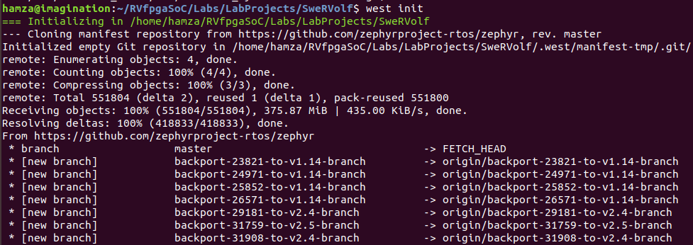

**………..**

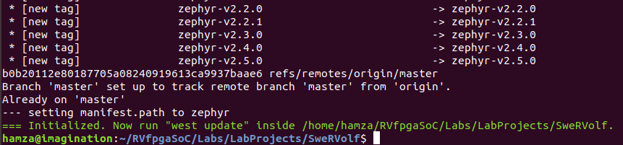

**Figure 3. west initialized**

**Step 3.** Add the SweRVolf-specific drivers and board support package (BSP) using the following command:

**$** west config manifest.path fusesoc_libraries/swervolf



**Figure 4. west config**

**$** west update

This may take several minutes to complete the downloading process, depending on your Internet download speed.

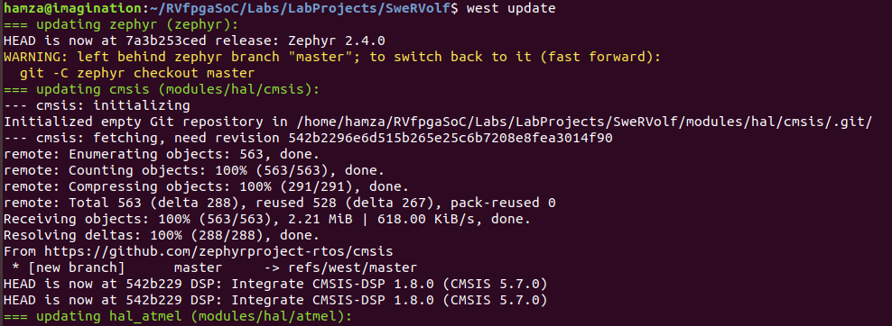

**………..**

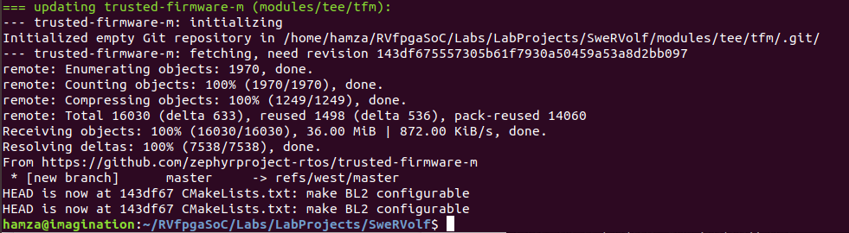

**Figure 5. west update**

The Workspace will now look like this :

$WORKSPACE

├──fusesoc_libraries

| ├──...

| └──swervolf

├──...

└──zephyr

# Building and Running Zephyr Applications On Verilator

In this section, we step through how to build programs that can run on Zephyr. Then we show how to simulate such programs on the Verilator simulator.We show two example programs in this section.

1. **Zephyr Hello World Example**

This example prints “**Hello World**” + “**Configured Board Name**” on the terminal.

See Figure 7 for the source code.

|  |
| --- |
| 1  2 #include <zephyr.h>  3 #include <sys/printk.h>  4  5 void main(void)  6 {  7 printk("Hello World! %s\n", CONFIG_BOARD);  8 }  9 |

**Figure 6. main.c of hello_world example**

**Step 1.** Go to the directory for this example, which is located at the following path:

$WORKSPACE/zephyr/samples/hello_world

To do so, use the following command:

**$** cd zephyr/samples/hello_world



**Figure 7. Navigate to the hello_world directory**

**Step 2.** Build the code for the “**hello_world**” Example using the following command :

**$** west build -b swervolf_nexys

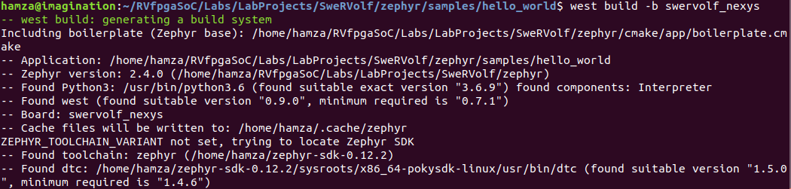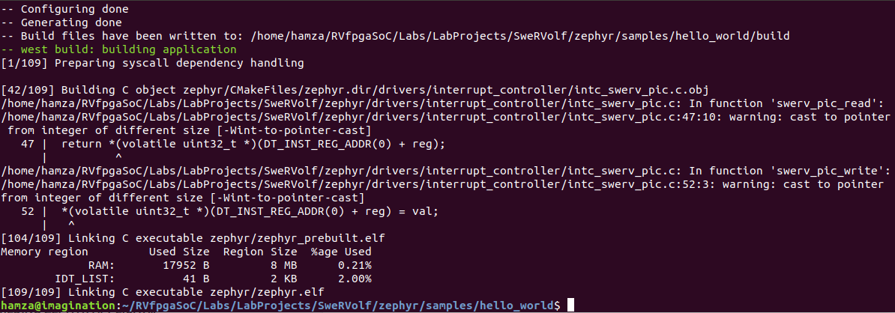

**Figure 8. hello_world build**

This will create the zephyr.elf and zephyr.bin files for the **hello_world** example. We will use the “**.bin**” file in a simulator, but it must first be converted into a suitable Verilog hex file.

**Step 3.**  Convert the “.bin” file to “.hex” file :

To create the “.hex” file, run the following command from the hello_world directory :

**$** python3 $SWERVOLF_ROOT/sw/makehex.py build/zephyr/zephyr.bin > /home/{YourUsername}/RVfpgaSoC/Labs/LabProjects/SweRVolf/zephyr/samples/hello_world/App.hex



**Figure 9. hello_world hex file created**

**Step 4.** Navigate to the WORKSPACE directory :

**$** cd $WORKSPACE



**Figure 10. Navigate to the main Workspace directory**

**Step 5.** Load the “.hex” file in the simulator :

**$** fusesoc run --target=sim swervolf --ram_init_file=zephyr/samples/hello_world/App.hex

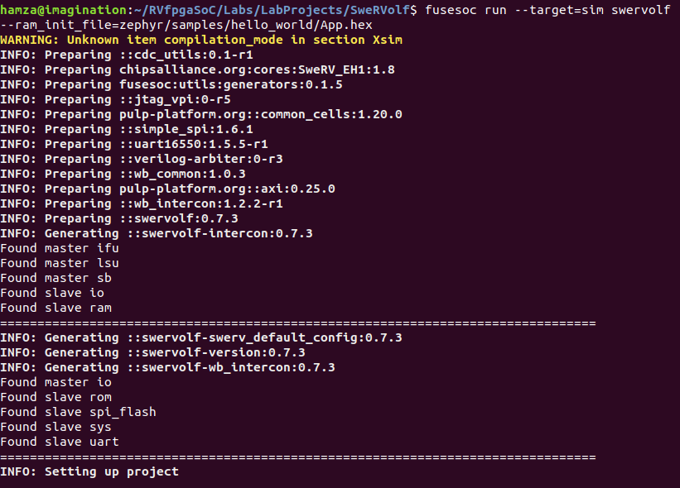

**Figure 11. fusesoc run**

The terminal will show the following output (see Figure 13).

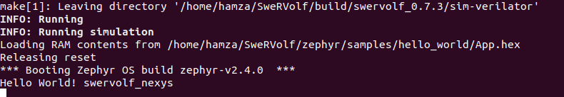

**Figure 12. hello_world example output**

Press “**Ctrl + C**” to stop the program.

1. **Zephyr Philosophers Example**

An implementation of a solution to the Dining Philosophers Problem (a classic multi-thread synchronization problem). This particular implementation demonstrates the usage of multiple preemptible and cooperative threads of differing priorities, as well as dynamic mutexes and causing a thread to sleep.

The philosopher always tries to get the lowest fork first (f1 then f2). When done, he will give back the forks in the reverse order (f2 then f1). If he gets two forks, he is EATING. Otherwise, he is THINKING. Transitional states are shown as well, such as STARVING when the philosopher is hungry, but the forks are not available, and HOLDING ONE FORK when a philosopher is waiting for the second fork to be available.

Each Philosopher will randomly alternate between the EATING and THINKING state.

Go to the following path to see the source code of this example :

$WORKSPACE/zephyr/samples/philosophers/src/main.c

For this example, we will repeat the same process again but in the philosophers directory

**Step 1.** This example program is in the following directory:

$WORKSPACE/zephyr/samples/philosophers

Change to that directory using the following command:

**$** cd zephyr/samples/philosophers



**Figure 13. Navigate to philosophers directory**

**Step 2.** Build the code for the philosophers example using the following command:

**$** west build -b swervolf_nexys

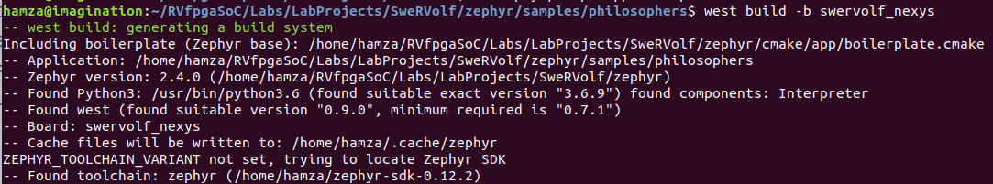

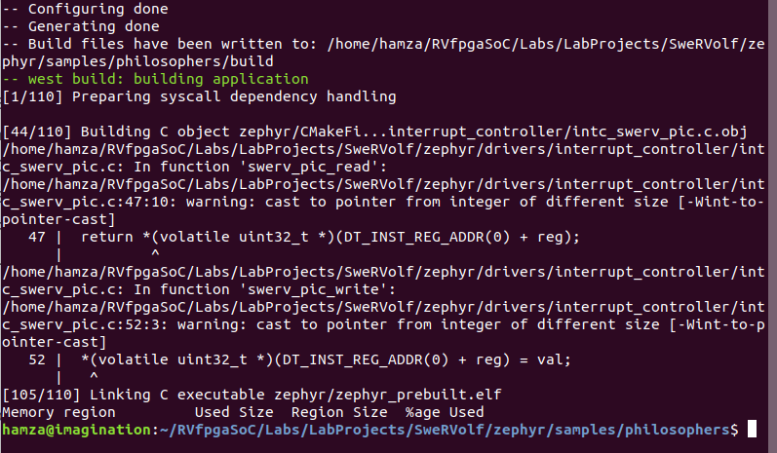

**Figure 14. philosophers build**

This will create the zephyr.elf and zephyr.bin files for the philosophers example. Again we will convert the “.bin” file into a suitable Verilog hex file.

**Step 3.**  Convert the “.bin” file to “.hex” file

To create the “.hex” file, run the following command from the hello_world directory :

**$** python3 $SWERVOLF_ROOT/sw/makehex.py build/zephyr/zephyr.bin > /home/{YourUsername}/RVfpgaSoC/Labs/LabProjects/SweRVolf/zephyr/samples/philosophers/App.hex



**Figure 15. Create philosophers hex file**

**Step 4.** Navigate to the WORKSPACE directory:

**$** cd $WORKSPACE



**Figure 16. main directory**

**Step 5.** Load the .hex file in the simulator:

**$** fusesoc run --target=sim swervolf --ram_init_file=zephyr/samples/philosophers/App.hex

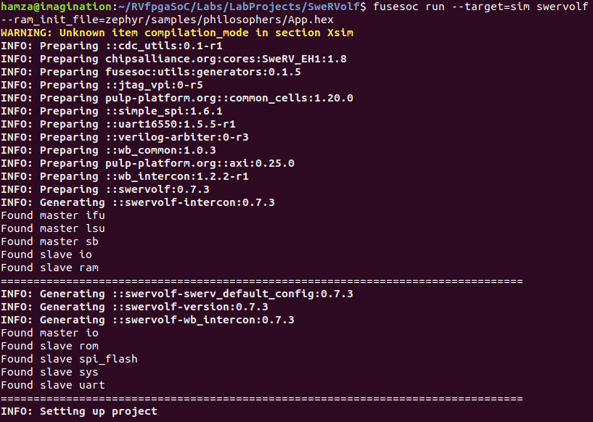

**Figure 17. fusesoc run**

Now you will see the following output:

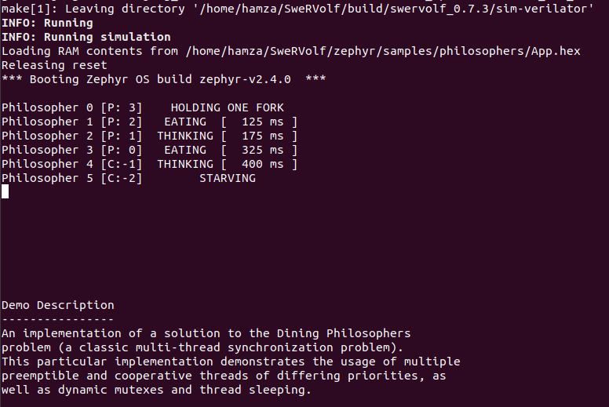

**Figure 18. Zephyr philosophers Output**

# Building Zephyr Application for Hardware

Now we show how to build programs for the SwerVolf running Zephyr in hardware.

1. **Zephyr Blinky Example**

Blinky is a simple application that blinks an LED forever using the:`GPIO

API <gpio_api>`. The source code shows how to configure GPIO pins as outputs,

then turn them on and off.

|  |
| --- |
| 1  2 /*  3 * Copyright (c) 2016 Intel Corporation  4 *  5 * SPDX-License-Identifier: Apache-2.0  6 */  7  8 #include <zephyr.h>  9 #include <device.h>  10 #include <devicetree.h>  11 #include <drivers/gpio.h>  12  13 /* 1000 msec = 1 sec */  14 #define SLEEP_TIME_MS 1000  15  16 /* The devicetree node identifier for the "led0" alias. */  17 #define LED0_NODE DT_ALIAS(led0)  18  19 #if DT_NODE_HAS_STATUS(LED0_NODE, okay)  20 #define LED0 DT_GPIO_LABEL(LED0_NODE, gpios)  21 #define PIN DT_GPIO_PIN(LED0_NODE, gpios)  22 #define FLAGS DT_GPIO_FLAGS(LED0_NODE, gpios)  23 #else  24 /* A build error here means your board isn't set up to blink an LED. */  25 #error "Unsupported board: led0 devicetree alias is not defined"  26 #define LED0 ""  27 #define PIN 0  28 #define FLAGS 0  29 #endif  30  31 void main(void)  32 {  33 const struct device *dev;  34 bool led_is_on = true;  35 int ret;  36  37 dev = device_get_binding(LED0);  38 if (dev == NULL) {  39 return;  40 }  41  42 ret = gpio_pin_configure(dev, PIN, GPIO_OUTPUT_ACTIVE | FLAGS);  43 if (ret < 0) {  44 return;  45 }  46  47 while (1) {  48 gpio_pin_set(dev, PIN, (int)led_is_on);  49 led_is_on = !led_is_on;  50 k_msleep(SLEEP_TIME_MS);  51 }  52 } |

**Figure 19. main.c of blinky example**

The path for this example is here:

$WORKSPACE/zephyr/samples/basic/blinky/

Navigate to the above path, and then run the following command in the terminal to build the example and generate “.elf” and “.bin” files :

**$** west build -b swervolf_nexys

After building the code, there will now be an executable **.elf** file in build/zephyr/zephyr.elf and a **.bin** file in build/zephyr/zephyr.bin.

The executable file can be loaded into SweRVolf with a debugger, and the binary file can be converted to a .hex file and loaded into RAM for simulations, as described in the next section.

# Running Zephyr Application on Hardware

To run the applications on the Nexys A7 board, we need to load the programs using OpenOCD:

**Step 1**. Connect the Nexys A7 board to your computer and then run the FPGA build command in the Workspace directory.

**$** fusesoc run --target=nexys_a7 --run swervolf

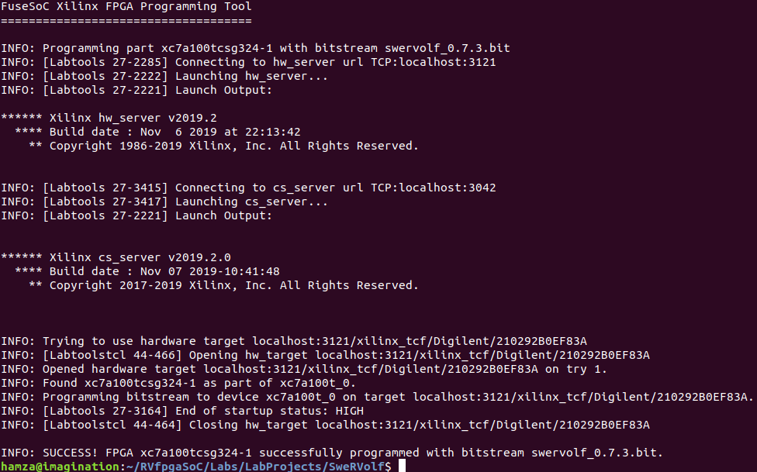

**Figure 20. Run FPGA Build**

**Step 2.** Program the board with OpenOCD.

**$** openocd -c "set BITFILE build/swervolf_0.7.3/nexys_a7-vivado/swervolf_0.7.3.bit" -f $SWERVOLF_ROOT/data/swervolf_nexys_program.cfg

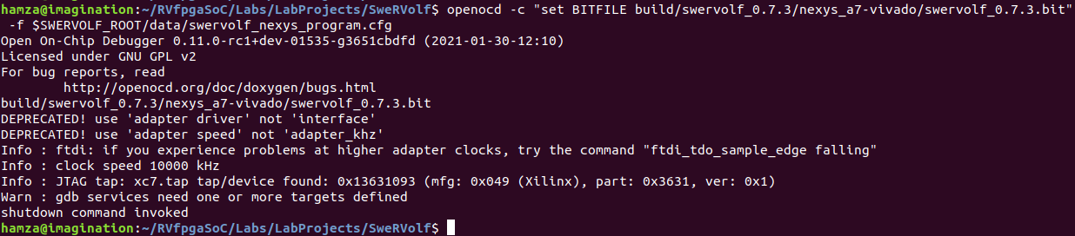**Figure 21. Run OpenOCD**

**Step 3.** Connect OpenOCD with SweRVolf.

**$** openocd -f $SWERVOLF_ROOT/data/swervolf_nexys_debug.cfg

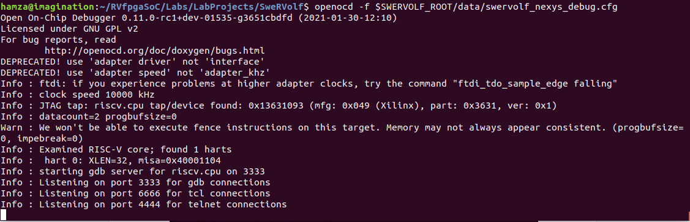

**Figure 22. OpenOCD Connected**

**Step 3**. Open a third terminal using “Ctrl + Shift + t” & connect to the debug session through OpenOCD using the following command:

**$** telnet localhost 4444

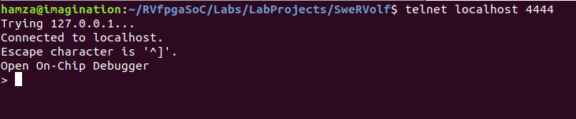

**Figure 23. telnet**

OpenOCD supports loading ELF program files by running *load_image /path/to/file.elf*. Remember that the path is relative to the directory from where OpenOCD was launched.

> load_image zephyr/samples/basic/blinky/build/zephyr/zephyr.elf

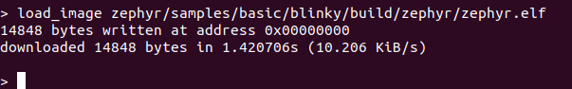

**Figure 24. load image .elf file**

After the program has been loaded, set the program counter to address zero using the following command:

**>** reg pc 0

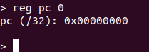

**Figure 25. Set program counter to zero**

Now start the program using this command:

**>** resume

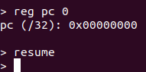

**Figure 26. Start the program**

Now you will see the right-most LED of the Nexys A7 board will start blinking.

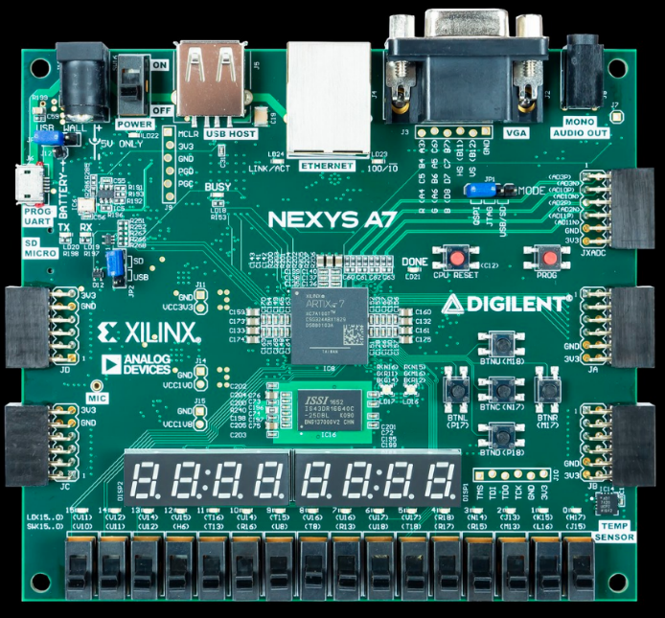

**Figure 27.LED Blinking**

# Zephyr Application Development Overview

Zephyr’s build system is based on CMake. The build system is application-centric and requires Zephyr-based applications to initiate building the kernel source tree. The application build controls the configuration and builds a process of both the application and Zephyr itself, compiling them into a single binary.

Zephyr’s base directory hosts Zephyr’s source code, its kernel configuration options, and its build definitions.

The files in the application directory link Zephyr with the application. This directory contains all application-specific files, such as configuration options and source code.

An application in its simplest form has the content listed here and described below:

/App

├── CMakeLists.txt

├── prj.conf

└── src

└── main.c

**CMakeLists.txt**: This file tells the build system where to find the other application files and links the application directory with Zephyr’s CMake build system. This link provides features supported by Zephyr’s build system, such as board-specific kernel configuration files, the ability to run and debug compiled binaries on real or emulated hardware, and more.

**Kernel configuration files**: An application typically provides a Kconfig configuration file (usually called prj.conf) that specifies application-specific values for one or more kernel configuration options. These application settings are merged with board-specific settings to produce a kernel configuration.

**Application source code files**: An application typically provides one or more application-specific files written in C or assembly language. These files are usually located in a subdirectory called **src**.

# Creating a New Zephyr Application

Follow these steps to create a new application directory.

**Step 1**. Change to the Samples directory:

**$** cd zephyr/samples

**Step 2**. Create a new directory for your application:

**$** mkdir my_first_app



**Figure 28. Make project directory**

**Step 3**. It is recommended to place all application source code in a subdirectory named src.

This makes it easier to distinguish between project files and source files:

**$** cd my_first_app

**$** mkdir src



**Figure 29. Make src directory inside the project directory**

**Step 4**. Enter the src directory and then create the application’s main source file, “main.c”.

**$** cd src

**$** nano main.c



**Figure 30. create “main.c” file**

Nano Editor will open up in your ubuntu terminal as shown in the figure below :

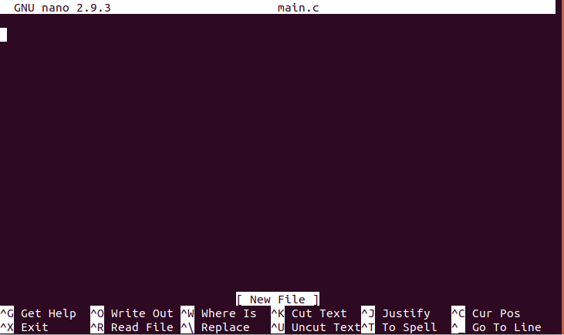

**Figure 31. GNU nano Editor**

**Step 5**. Copy the following code in the nano editor. This code is the mixture of both the “hello_world” and the “blinky” example source code.

|  |
| --- |
| #include <zephyr.h>  #include <sys/printk.h>  #include <device.h>  #include <devicetree.h>  #include <drivers/gpio.h>  /* 1000 msec = 1 sec */  #define SLEEP_TIME_MS 1000  /* The devicetree node identifier for the "led0" alias. */  #define LED0_NODE DT_ALIAS(led0)  #if DT_NODE_HAS_STATUS(LED0_NODE, okay)  #define LED0 DT_GPIO_LABEL(LED0_NODE, gpios)  #define PIN DT_GPIO_PIN(LED0_NODE, gpios)  #define FLAGS DT_GPIO_FLAGS(LED0_NODE, gpios)  #else  /* A build error here means your board isn't set up to blink an LED. */  #error "Unsupported board: led0 devicetree alias is not defined"  #define LED0 ""  #define PIN 0  #define FLAGS 0  #endif  void main(void)  {  const struct device *dev;  bool led_is_on = true;  int ret;  dev = device_get_binding(LED0);  if (dev == NULL) {  return;  }    ret = gpio_pin_configure(dev, PIN, GPIO_OUTPUT_ACTIVE | FLAGS);  if (ret < 0) {  return;  }  while (1) {  gpio_pin_set(dev, PIN, (int)led_is_on);  led_is_on = !led_is_on;  k_msleep(SLEEP_TIME_MS);  printk("This Zephyr Application is Running on %s\n", CONFIG_BOARD);  }  } |

**Figure 32. “main.c” code**

After you are finished writing the code, press “**Ctrl + x**” to exit.

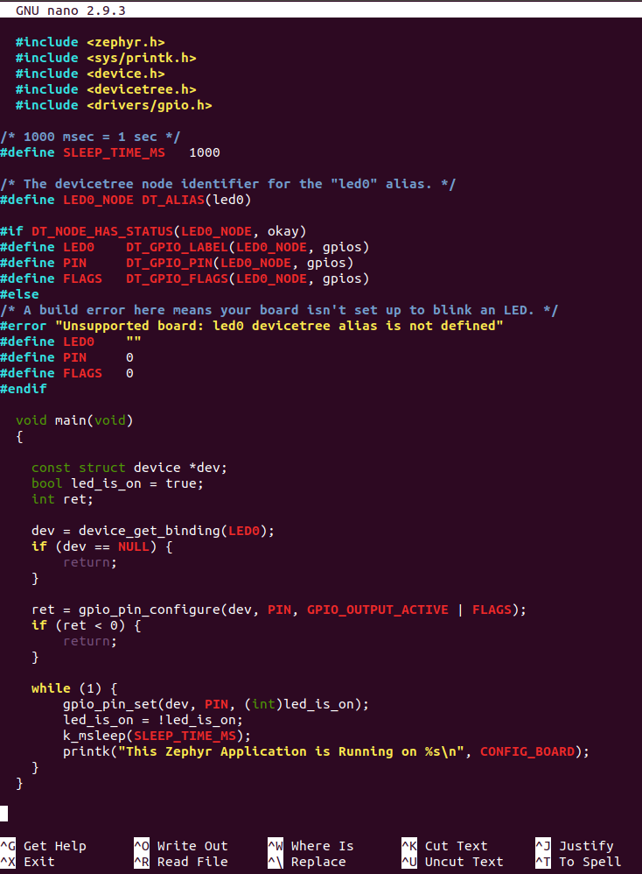

**Figure 33. main.c file code**

Then it will ask you if you want to save the file, and you have to press “**y**” for Yes.



**Figure 34. save main.c file**

Press “**Enter**” to save the file with the name “main.c”.



**Figure 35. confirm the name main.c**

**Step 6**. Now we need to navigate out of the src directory and then create the “**CMakeLists.txt**” and “**prj.conf**” files :

**$** cd ..

**$** nano CMakeLists.txt



**Figure 36. Create CMakeLists.txt**

Copy the following code to the nano editor:

|  |
| --- |
| cmake_minimum_required(VERSION 3.13.1)  find_package(Zephyr REQUIRED HINTS $ENV{ZEPHYR_BASE})  project(my_first_app)  target_sources(app PRIVATE src/main.c) |

**Figure 37. “CMakeLists.txt” file code**

Now perform the same steps that you have done in order to save the “main.c” file.

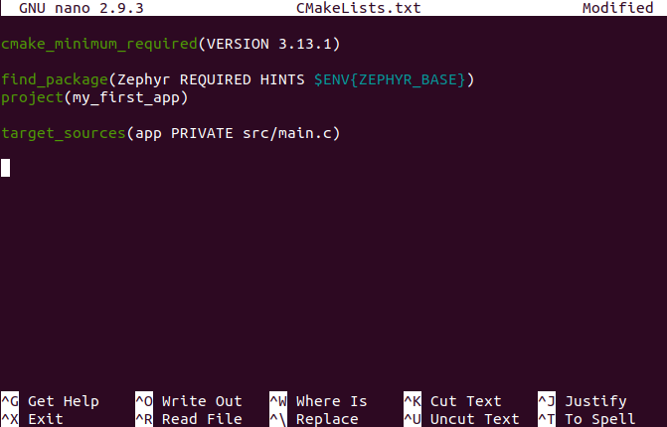

**Figure 38. nano editor**

Now create the project configuration file.



**Figure 39. create a project configuration file**

Application configuration options are set in prj.conf in the application directory. Since we are using an LED in our source code; so we have to set the “CONFIG_GPIO” parameter as yes.

|  |
| --- |
| CONFIG_GPIO=y |

**Figure 40. “prj.conf” code**

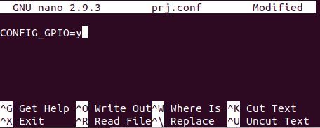

**Figure 41. “prj.conf” nano editor**

Now save the “prj.conf” file.

**Step 7**. Build the code for “**my_first_app**”:

**$** west build -b swervolf_nexys

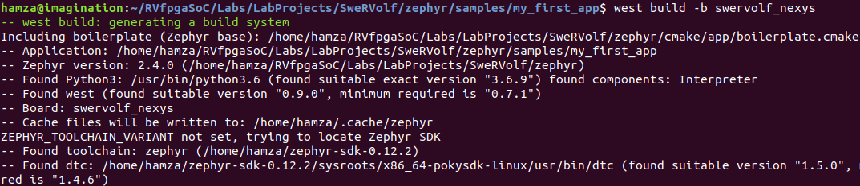

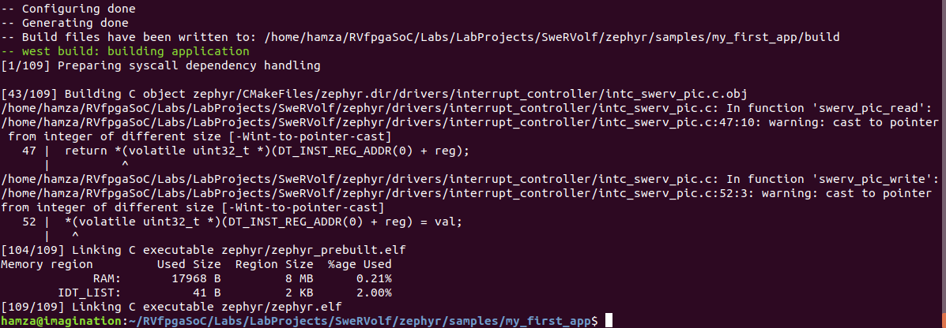

**Figure 42. “my_first_app” build**

The binaries have been generated successfully. Now we will run the “my_first_app” program on the Nexys A7 board.

**Step 9.** Navigate to the WORKSPACE directory:

**$** cd $WORKSPACE



**Figure 43. Navigate to the Workspace directory**

**Step 10**. Connect the Nexys A7 board to your computer and then run the FPGA build command in the Workspace directory.

**$** fusesoc run --target=nexys_a7 --run swervolf



**Figure 44. Run FPGA Build**

**Step 11.** Program the board with OpenOCD.

**$** openocd -c "set BITFILE build/swervolf_0.7.3/nexys_a7-vivado/swervolf_0.7.3.bit" -f $SWERVOLF_ROOT/data/swervolf_nexys_program.cfg



**Figure 45. Run OpenOCD**

**Step 12.** Connect OpenOCD with SweRVolf.

**$** openocd -f $SWERVOLF_ROOT/data/swervolf_nexys_debug.cfg



**Figure 46. OpenOCD Connected**

**Step 13**. Open a third terminal using “Ctrl + Shift + t” & connect to the debug session through OpenOCD using the following command:

**$** telnet localhost 4444



**Figure 47. telnet**

OpenOCD supports loading ELF program files by running *load_image /path/to/file.elf*. Remember that the path is relative to the directory from where OpenOCD was launched.

> load_image zephyr/samples/basic/blinky/build/zephyr/zephyr.elf



**Figure 48. load image .elf file**

After the program has been loaded, set the program counter to address zero using the following command:

**>** reg pc 0



**Figure 49. Set program counter to zero**

Now start the program using this command:

**>** resume



**Figure 50. Start the program**

The LED on the board will start blinking.

**Step 14**. Open a new terminal tab using “Ctrl + Shift + t” and open PuTTY using the following command:

**$** putty



**Figure 51. open PuTTY**

We will be using PuTTY here as a serial console for our Nexys A7 board.

**Step 15**. Set the following configuration:

Select the connection type as “**serial**”, then enter “**/dev/ttyUSB1**” as the serial line, and set the speed equal to “**115200**”.

Now click “Open” to start the serial console.

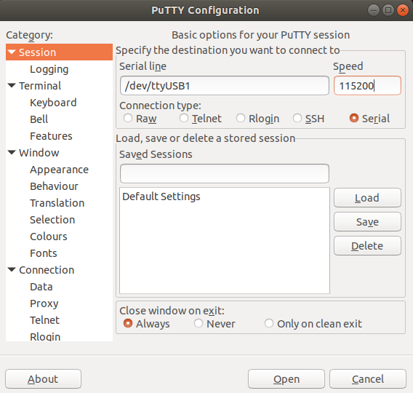

**Figure 52. PuTTY Configuration**

In the serial console, we can see the output of our program “my_first_app” (See Figure 54).

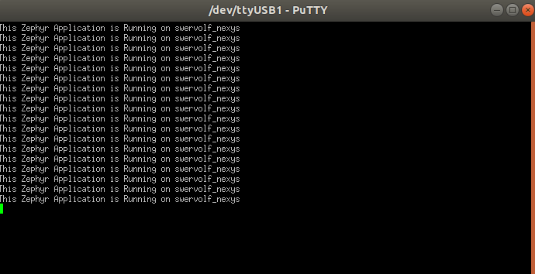

**Figure 53. serial console output**

|  |
| --- |
| **Note**: If you are unable to open a serial console, try running putty as an Administrator using “sudo” or try “/dev/ttyUSB0” as the serial line. |

As we can see in the output text on the serial console, This zephyr application is running on SweRVolf Nexys.